}

1. **PARTE I**

| **1. Personal Information** |
| --- |
|  |

| Student Names | **Bastian Medina, Roni Saavedra, Maximiliano Pino** |
| --- | --- |
| Rut | **20.829.306-0 ,21.446.932-4 ,21.066.376-2** |
| Degree | **Computer Engineering** |
| Campus | **Maipú** |

| **2. APT Project Description** |
| --- |
|  |

| Project Name | **Point of Sale with Inventory Control for *Plantitas donde la Fran*** |
| --- | --- |
| Performance Area(s) | *Software Development, Databases, Requirements Engineering* |
| Competencies | *Develop software solutions applying appropriate methodologies, languages, and frameworks.*  *Implement and manage relational databases to ensure integrity and efficiency in data management.*  *Analyze functional and non-functional requirements to design technological solutions that meet client needs.*  *Manage software projects by applying agile methodologies.* |

| **3.APT Project Justification** |
| --- |
|  |

| Project Relevance | *The business Plantitas donde la Fran, dedicated to selling plants, currently manages sales and inventory manually. This creates difficulties in stock control, increases service time, and prevents having consolidated information for decision-making. Creating a web platform will help optimize processes, reduce errors, and improve business management. For the Computer Engineering program, this project is relevant because it addresses a real digitalization problem in microenterprises, providing a concrete contribution to the labor field in software development.* |
| --- | --- |
| Project Description | *A web platform will be developed with a sales module to register transactions, an inventory module that automatically updates stock, and a basic reporting system (daily sales, best-selling products). In addition, a user module with differentiated roles (administrator and seller) will be included. The solution will be developed using React (frontend), Django (backend), and mariadb (database), following an agile work approach.* |
| Relevance to Graduate Profile | *This project allows applying key graduate competencies such as software design and development, database implementation, and project management using agile methodologies. All of these are essential to address the identified problem and deliver an efficient and scalable technological solution.* |
| Relation to Professional Interests | *The project directly relates to my professional interests in the area of software development and in implementing solutions that help optimize processes in small and medium-sized businesses. It will allow me to strengthen my knowledge in modern frameworks, databases, and agile methodologies, contributing to my growth as a future computer engineer.* |
| Project Feasibility | *The project is feasible to develop during the semester, considering the subject duration and assigned hours. The necessary technological resources (computer, internet access, free software, and databases) are available. Facilitating factors include the client’s willingness (Plantitas donde la Fran) to provide feedback and validate progress. Possible difficulties include tight schedules and the learning curve of some technologies, which will be mitigated through weekly planning and the use of agile methodologies.* |

1. **PARTE II**

| **4. Objectives** |
| --- |
|  |

| General Objective | *The main objective of this project is to create a web platform that helps Plantitas donde la Fran manage its sales and inventory in a simpler and more organized way. With this tool, the business will be able to record transactions, automatically update stock, and generate basic reports that support better decision-making, making management faster and more efficient.* |
| --- | --- |
| Specific Objectives | *Design a sales module that allows transactions to be recorded quickly and easily, making the business’s daily work easier.*  *Create an inventory module that automatically updates stock every time a sale or purchase is made, to maintain more reliable and organized product control.*  *Incorporate a reporting system, such as daily sales and best-selling products, to support decision-making when purchasing new merchandise.*  *Develop the platform using JavaScript, Node.js, React, Python, Django, and mariadb, ensuring the system meets what was planned and takes advantage of the selected technologies for good performance.* |

| **5. Methodology** |
| --- |
|  |

| Methodology Description |
| --- |
| *The project will be developed using the* ***Kanban*** *approach, which allows visual management of the workflow, showing the current stage of each task and facilitating prioritization of activities. This methodology adapts to the reality of the project by providing flexibility, progress control, and a focus on continuous value delivery.*  ***Work Stages:***   1. ***Initial requirements gathering****: meeting with the client (Plantitas donde la Fran) to define priority features.* 2. ***Solution design****: creation of the database model and interface wireframes.* 3. ***Task organization in Kanban board****: structuring the workflow into columns (“To Do,” “In Progress,” “Under Review,” “Completed”).* 4. ***Incremental development****: implementation of functionalities in Django (backend), React (frontend), and MySQL, progressing in small batches.* 5. ***Testing and validation****: continuous review with the client, ensuring quality and alignment with requirements.* 6. ***Final delivery****: deployment of the system in a local environment, with technical documentation and user manual.*   ***Roles and Responsibilities:***   * ***Project Lead (student)****: planning, development, and documentation.* * ***Client (Fran)****: requirements validation, acceptance testing, and feedback.* |

| **6. Evidence** |
| --- |
|  |

| **Type of Evidence** | **Name of Evidence** | **Description** | **Justification** |
| --- | --- | --- | --- |
| Progress | User Stories and Backlog | Prioritized stories based on client requirements | Facilitates agile development and task management |
| Final | Web Platform | Point of sale system with inventory and basic reports | Main deliverable that solves the identified problem |
| Final | *mariadb* Database | Relational structure to manage sales and inventory | Ensures integrity and efficiency in data management |
| Final | Technical Documentation and User Manual | Explains the design, architecture, and use of the solution | Facilitates system use and maintenance |

| **7. Plan de Trabajo** |
| --- |
|  |

| **Work Plan** | | | | | | |
| --- | --- | --- | --- | --- | --- | --- |
| Competence or Unit of Competence | Activity / Task Name | Activity / Task Description | Resources | Duration | Responsible[1] | Observations |
| *Requirements Analysis* | Requirements Gathering | Meetings with the client to identify needs and define scope | *PC, internet, client available* | *1 week* | Bastian Medina, Roni Saavedra, Maximiliano Pino | May require adjustments depending on client availability |
| *Software Design* | *Create Use Cases and Diagrams* | *Define system operation through diagrams and use cases* | *Modeling tools (Draw.io), PC* | *1 week* | *Bastian Medina, Roni Saavedra, Maximiliano Pino* | *Requires clear requirements to avoid rework* |
| *Software Engineering* | *Database Design* | *Define entity-relationship model and table structure in MySQL* | *mariadb, PC* | *1 week* | *Bastian Medina, Roni Saavedra, Maximiliano Pino* | *Validate necessary fields with the client* |
| *Backend Development* | *Django Implementation* | *API programming for sales, inventory, and users* | *PC, Python, Django* | *3 weeks* | *Bastian Medina, Roni Saavedra, Maximiliano Pino* | *May extend depending on complexity* |
| *Frontend Development* | *React Implementation* | *Create user interfaces to record sales, manage stock, and generate reports* | *PC, Node.js, React* | *3 weeks* | *Bastian Medina, Roni Saavedra, Maximiliano Pino* | *Must coordinate with backend* |
| *Module Integration* | *Connect Frontend, Backend, and Database* | *Integrate the three components to function as one system* | *PC, test server, technical documentation* | *1 week* | *Bastian Medina, Roni Saavedra, Maximiliano Pino* | *Risk of incompatibilities between modules* |
| *Validation and Testing* | *Functional Tests* | *Perform unit and integration tests with client feedback* | *PC, test data* | *1 week* | *Bastian Medina, Roni Saavedra, Maximiliano Pino + Client* | *Adjustments may be required depending on results* |
| *Final Documentation* | *Technical Documentation and User Manual* | *Write usage manual and technical guide for the system* | *Word, PDF* | *2 weeks* | *Bastian Medina, Roni Saavedra, Maximiliano Pino* | *Final deliverable alongside the platform* |

| **8. ROADMAP** |
| --- |
|  |

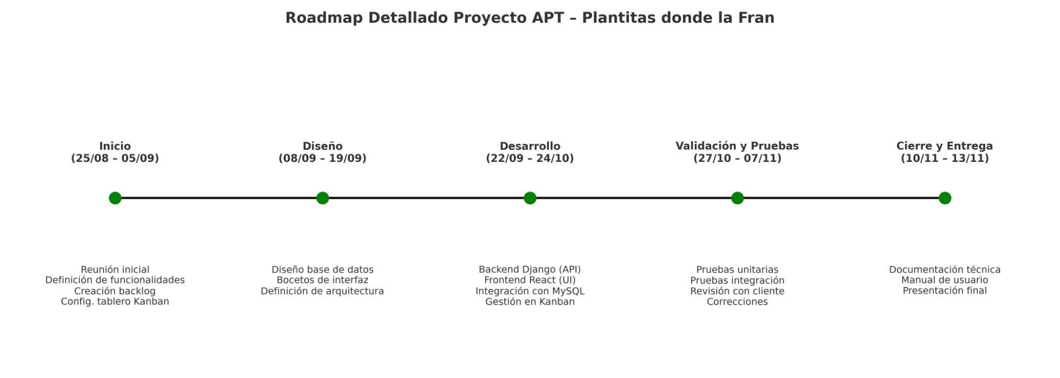

1. En caso de que el Proyecto APT sea grupal, en esta columna deben indicar el nombre de los responsables de cada tarea o actividad. Esto posteriormente permitirá diferenciar la evaluación por cada integrante.